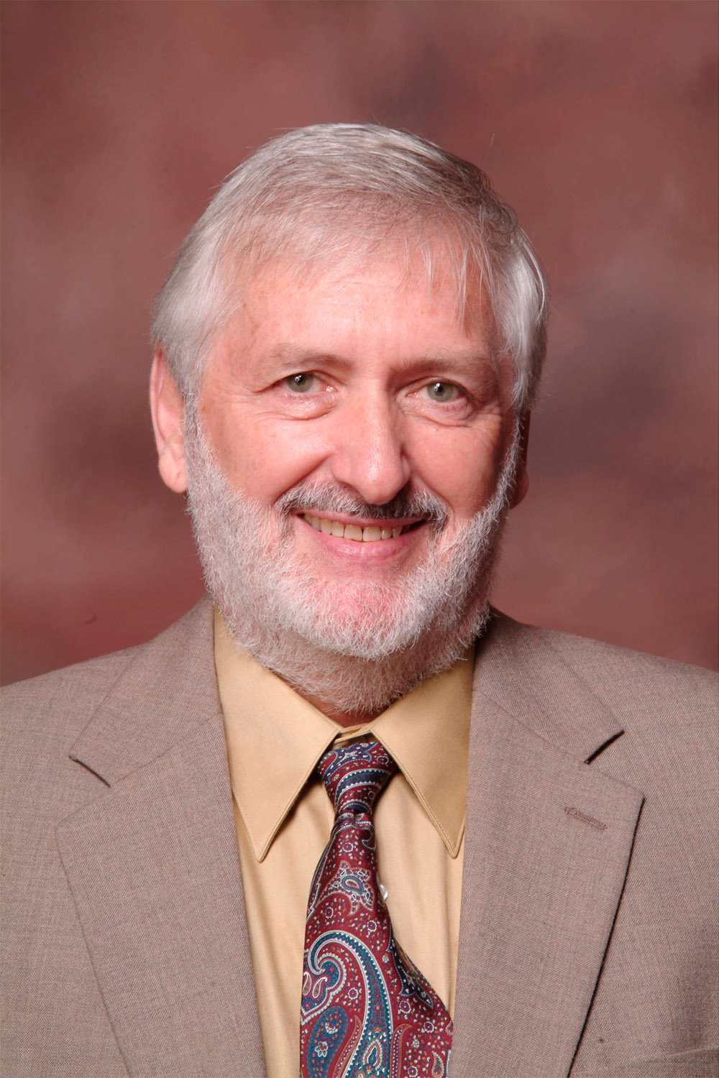

The Dr. Paul A. Fox Scholarship was developed to honor the longest serving faculty member at Appalachian State University across all departments (1970-2018). He served in the U.S. Air Force, earned a degree in Psychology from Hofstra University on a GI scholarship, and a PhD at Southern Illinois University in Experimental Psychology. At Appalachian, Paul, as he preferred to be called, served as Graduate Coordinator (1987-1996) and Department Chair (2003-2008). At the state level, he served as Commissioner of the NC State Testing Commission (1985-1996). In the first year at Appalachian (1970-71), he was the recipient of the University Outstanding Teacher Award, an honor bestowed on only three university faculty members each year. In 1977, he was awarded the Outstanding Teacher Corps Demonstration Project by the U.S. Office of Education. In 1995, the NC Bureau for Educational Research named his Teaching of Psychology course one of two outstanding programs statewide for training graduate training assistants in North Carolina.

Paul championed the use of behavioral psychology in educational settings for increasing student learning and managing student behavior. In 1972, Paul received a Ford Foundation Venture Grant to develop a self-paced Personalized System of Instruction (PSI) program in Educational Psychology. He developed a token economy program for juveniles that the NC legislature mandated for all Juvenile Evaluation Facilities in the state. His token system was also implemented at an at-risk elementary school and the outcome appeared in a NEA magazine in 1974. More recently, Paul’s research has focused on the intersection of psychology and the law. He has published with his students in well-respected peer-reviewed journals including Behavioral Sciences and the Law, Journal of Forensic Psychology, and the Journal of Interpersonal Violence.

Paul has influenced tens of thousands of students. Many have noted the important influence he had on their career decisions, his compassion, and the degree to which he influenced the way they thought about Psychology. One former student, Dr. Michael T. Allen, past chair and now a professor at the University of Mississippi, wrote, “I was lucky enough to have Dr. Paul Fox chair my Masters thesis very early in his career at Appalachian. He was a young man with only a couple of years of faculty experience at that time, but he nonetheless left a lasting influence on my academic career. He clearly possessed an outstanding intellect and a wide-ranging body of knowledge in the field of psychology, but he was also funny and approachable with an undeniable charisma. To me, he was a template for being a successful and well-liked faculty member, and my interactions with him during my time at Appalachian have impacted positively on my academic career. Appalachian has been extremely lucky to have such a wonderful role model for students over his long, productive career.”

FOX SCHOLARSHIP INFORMATION

The Fox Scholarship was founded in honor of Dr. Paul Fox to provide financial support for undergraduate students seeking to participate in research in the psychology department.

Description
1. Scholarship amounts will be allocated to one or two students in the minimum amount of $500 per student as determined by Fox Scholarship Committee.
2. Students may request that funds be used to support research costs, travel to professional conferences, or to cover tuition.

Eligibility
- Full time psychology major in junior year.
- Demonstrated interest in psychological research by working in a psychology faculty member’s research lab continuing into their senior year.
- Satisfactory academic status: minimum 3.0 GPA in major and overall by the end of their first junior semester.
- Verified financial need.
Selection Criteria

- Scholastic merit.
- Financial need.
- Quality of application.
- Two Recommendations (by psychology department faculty members, one must be a research mentor).

Application Procedure
1. Applicants must submit the following materials by April 21st, 2021 by noon.
a. Completed Fox Scholarship application form.
b. A copy of all undergraduate college/university transcripts (this can be an unofficial transcript from appalnet).
c. Two letters of support by psychology department faculty members (one must be a research lab mentor).
2. Recipient(s) will be notified before the end of the current semester. The selection committee may ask finalists to complete on-line interviews in April.
3. Return application, Transcripts and Reference Forms to:

Dr. Chris Holden

Appalachian State University
Department of Psychology
holdencj@appstate.edu

- Incomplete applications, (e.g., lack of completed reference forms or lack of transcripts) will not be considered. Completed applications are the applicant's responsibility.
- Questions regarding the application procedure should be directed to Dr. Chris Holden (holdencj@appstate.edu).
- Applicants are responsible for checking on the status of their application prior to the deadline date.

APPLICATION

THE DR. PAUL FOX SCHOLARSHIP

1. PERSONAL INFORMATION Student ID Number 900____________

Name:_____________________________________________________________________
Last First Middle

Permanent Address:__________________________________________________________
Street/PO Box
__________________________________________________________
City State Zip Code

Telephone ( ) ________________________

Local Address:_______________________________________________________________
Street/PO Box
_______________________________________________________________
City State Zip Code

Telephone ___________________ email ____________________________

Date of Birth: _____________________________ Sex: M _____ F _____

2. COLLEGE RECORDS

University Class: Junior ______ Senior ______

Minor ______________ and/or Concentration _____________

Undergraduate GPA ________ Psychology GPA________
(minimum 3.0 cumulative) (minimum 3.0)

College/University Address Dates Degree

_________________________ _____________________ _________ ________

_________________________ _____________________ _________ ________

_________________________ _____________________ _________ ________

_________________________ ____________________ __________ ________

(attach additional sheet if necessary)

3. REFERENCES

Please provide the names of two psychology faculty who are familiar with your academic
record and interest in a career in psychology. At least one reference must be a research lab mentor in the department.

1. _______________________________________________ ( ) ________________
Name (Appalachian Professor) Department Telephone

2. _______________________________________________ ( ) ________________

Name (Appalachian Professor) Department Telephone

4. EDUCATIONAL INFORMATION (attach additional sheet if necessary)

Academic Honors: ___________________________________________________________

____________________________________________________________________________

____________________________________________________________________________

____________________________________________________________________________

Extracurricular Activities:_____________________________________________________

____________________________________________________________________________

____________________________________________________________________________

____________________________________________________________________________

Leadership Experience: _______________________________________________________

____________________________________________________________________________

____________________________________________________________________________

Work Experience: ___________________________________________________________

____________________________________________________________________________

____________________________________________________________________________

____________________________________________________________________________

Write a statement explaining factors that influence your financial need: (e.g., list financial
aid, scholarships or grants already being received; state if you are financially independent;
how much financial aid debt you have to date; are you working to pay for expenses, if so how many hours per week)

____________________________________________________________________________

____________________________________________________________________________

____________________________________________________________________________

____________________________________________________________________________

____________________________________________________________________________

____________________________________________________________________________

(attach additional sheet if necessary)

Date ______________________ Applicant's Signature ___________________________

5. APPLICANT'S STATEMENT

Write a statement detailing your professional goals, and how attainment of these will be facilitated by your research experience (which should be described in detail as well). This statement is to be a maximum of two double spaced typed pages.

REFERENCE FOR THE DR. PAUL FOX SCHOLARSHIP

Reference for (Applicant Name): ________________________________________________

Please attach a reference regarding the applicant's qualifications for a scholarship in the Department of Psychology including: (a) how long you have known the applicant and in
what capacity, (b) scholastic merit, (c) strengths and weaknesses of the applicant, (d) commitment to a career in psychology, (e) why you think the applicant is deserving of this scholarship (including financial need).

Signature ______________________________
Email your reference to

Dr. Chris Holden holdencj@appstate.edu
Appalachian State University
Department of Psychology

By April 21, 2021 by noon

Name __________________________________
(type or print)

Position _______________________________

Address _______________________________

Street/PO Box

_______________________________________
City State Zip Code

REFERENCE FOR THE DR. PAUL FOX SCHOLARSHIP

Reference for (Applicant Name): ________________________________________________

Please attach a reference regarding the applicant's qualifications for a scholarship in the Department of Psychology including: (a) how long you have known the applicant and in
what capacity, (b) scholastic merit, (c) strengths and weaknesses of the applicant, (d) commitment to a career in psychology, (e) why you think the applicant is deserving of this scholarship (including financial need).

Signature ______________________________
Email your reference to

Dr. Chris Holden
holdencj@appstate.edu
Appalachian State University
Department of Psychology

By April 21, 2021 by noon

Name __________________________________
(type or print)

Position _______________________________

Address _______________________________

Street/PO Box

_______________________________________
City State Zip Code

